

HackerRank Grade Report

Name : Yumnam Khristan Singh
Enrollment ID : ADTU/1/2025-28/BCAO/046
Semester : 2
Sec : C
Previous Semester Hackos point Screenshot :
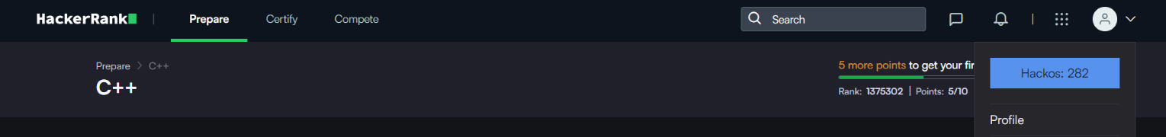

Current Semester Hackos point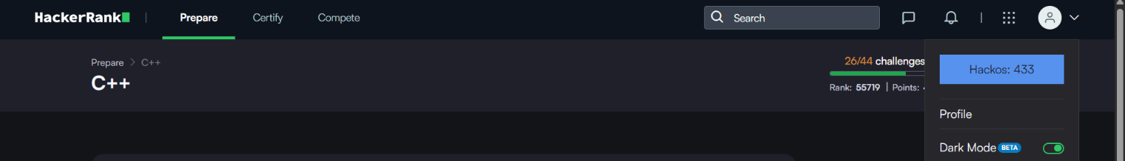

Rank : 55723
Point : 465
Rank and Point Screenshot :

